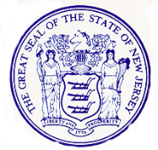
State of New Jersey
MIKIE SHERILL
Governor

DR. DALE G. CALDWELL
Lt. Governor

STEPHEN CHA, MD, MHSR
Acting Commissioner

DEBORAH ROBINSON
Director

Department of Human Services

Office of Program Integrity and Accountability

P.O. BOX 700

TRENTON NJ 08625-0700

Office: (609) 292-0207 – Fax: (609) 943-3029

TO: Data Reduction

State Bureau of Identification (SBI)

Thru: Connie Jeremias, Director – Cost Code# 700
Employee Controls and Compliance Unit (ECCU)
Department of Human Services (DHS)

COST CODE: Enter Application Type and Cost Code Number

DATE:

SUBJECT: Flag Removal

Request the following individual(s) flag(s) be removed from the SBI files:

Name: | DOB: | SSN: | PCN or TCN:

Send completed Flag Removal Forms to ECCU’s office inbox at Dhs.Eccu@dhs.nj.gov

